OUT BOUND DIALER (OBD)
Features of service:
Control Panel: Web Based
Integration: Https URL Base Campaign Management
Reports: Real Time Web-based & API based
Outbound Dialing (OBD)
Outbound Dialing (OBD) is a robust system designed to effectively manage automated bulk outbound dialling without any Capex Cost.
The system had option of
- Instantly Dial-out
Or
- Schedule dial-out to a list of mobile users uploaded by the customer as per his requirement.
It an effective tool which any Enterprise requires for its various activities like subscription reminders, alerting to subscriptions, Product Launch etc. Thereby adding immense value over manual operation of such activities on large numbers Database.
Reports can be generated on the Basis of call status.
Key Features
OBD-Outbound Dialer is an automated dialing system that generates simultaneous voice calls to a list of pre identified phone numbers of a target group.
OBD is a powerful, cost-effective Tele-marketing Communication service to promote various programs, advertisements, offers and value-added services to customers with reduced cost and time.
OBD provides reach to more than thousands of target customers in diversified languages.

How it Works
OBD Types
A) Promotional B) Transactional
- Promotional :- In promotional type, Call send from 0120,0731 CLI number and DND data has been filter ( which means call not send to the DND numbers)
- Transactional: - In Transactional type, call send from 0120,0731 CLI number and DND data has been not filter in it.

Login with the panel details with the shared login http://125.17.101.174/faces/soundAlbum.xhtml

User name: - xyz
Password: - Abc@1234
Select service type: - OBD

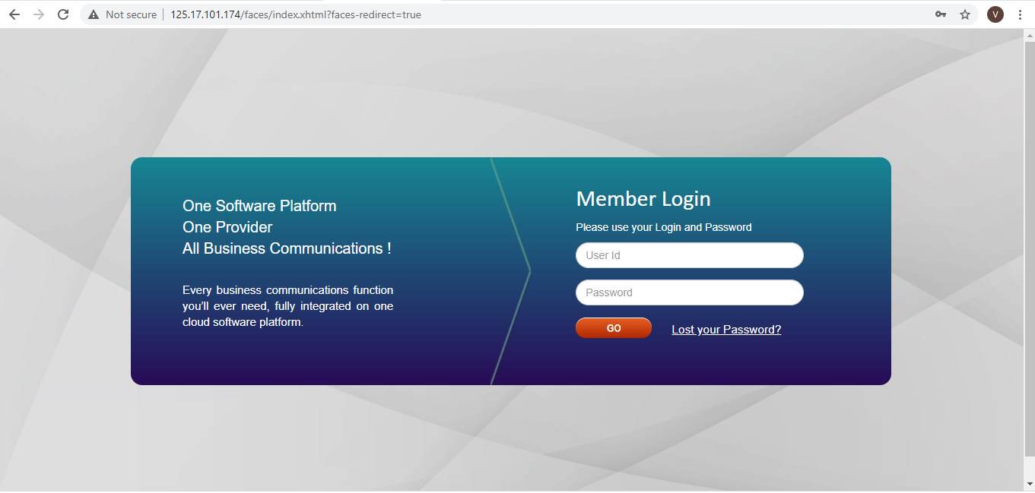

Dashboard Detail: - Screen shot

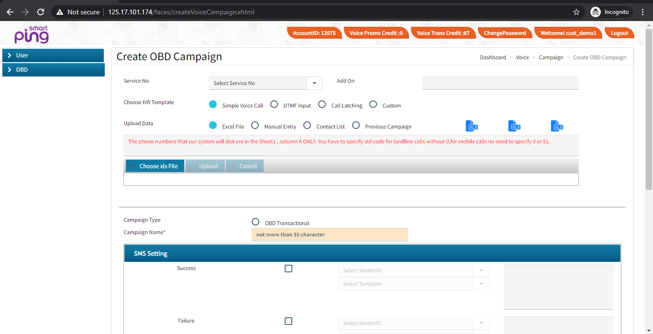

- User ID: User can view user id.
- Credits:- User can view balance voice credits(Trans/promo)
- Campaign Report: User can view real time Campaign Detail.

Option under OBD Interface
- GUI
GUI: Graphical user interface where user login to system with valid login Credentials and operate OBD interface.

B) Https based Web Service
API: API stands for Application Programming Interface. We have json based api. It works on POST method. User can integrate his application with our API to automate his processes. User name password will be same as used in GUI.

Client Dashboard with it’ A/c Details

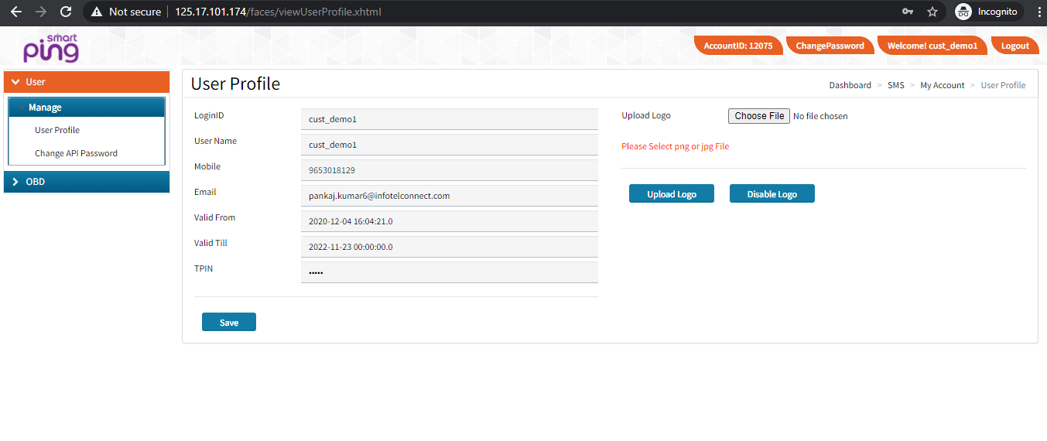

Various OBD Campaign Modules:-

- Voice File approval process:
  - User will upload voice file on the GUI portal.
  - Format of the Voice file .wav(Auto approval)
- Action required for Campaign Creation: Need to capture and Upload the details as mention below against the Log-in account
  - Service no. – Select allocated service no.
  - Choose IVR Template —
    - Simple Voice Campaign
    - OBD with DTMF
    - Call Latching
    - Customization OBD
  - Upload data — Upload Dial-out Number’s Base(excel file format, manual, contact list, previous campaign)
  - OBD type – Promo/Trans
  - Campaign Name
  - Option of Send SMS if required , mention API /content after required approvals
  - Upload Voice file
  - Mention Retry count if required
  - Retry Interval—applicable in case of Retry
  - OBD Campaign Type :-
    - Current
    - Scheduled
- Upload Dial-out Number’s Base(excel file format, manual, contact list, previous campaign)

Activity completed for campaign execution
NOTE: - All fields are mandatory
- Campaign report: - User can View & fetch campaign report.
- Child campaign report:-Reseller can see your child account campaign details.
- Sound:-:- User can view and upload voice file here.

- Upload voice fields:
- Voice file Name
- OBD type(trans/promo)
- Upload voice file ( .wave format 16bits , 8000hz , mono)

- Phonebook: - User can view and uploaded contact group.
- My Account: - User can view approved API document.

In a case, Customer requirement for redirecting the panel with domain, Then we will share the IP based URL to the customer.

---------------------------------------------------------------------------------------------------------------------------------------

